***Online Service Management System***

***Submitted By:***

***Raj Kumar***

**Enr. No.- 12345678**

***(2018– 19)***

***Under the Guidance of :***

**Mr. Rahul Kumar**

**Submitted to the School of Computer and Information Science In Partial fullfillment of the requirements for the degree of**

**Master of Computer Application**



**Index**

|  |  |  |
| --- | --- | --- |
| SI.NO | CONTENTS | PAGE NO. |
| 1. | Title of the project | 3-3 |
| 2. | Introduction | 4-4 |
| 3.  4. | Objectives  Project Category | 5-5  6-6 |
| 5. | Diagrams |  |
|  | 5.1 DFD 0 Level | 7-7 |
|  | 5.2 DFD 1 Level | 7-7 |
|  | 5.3 E R Diagram | 8-8 |
|  | 5.4 Flow Chart | 9-9 |
| 6. | Modules and their description | 10-11 |
| 7. | Input/output modules of the project |  |
|  | 7.1 Input modules of the project | 12-12 |
|  | 7.2 Output modules of the project | 12-12 |
| 8. | Process logic | 13-16 |
| 9. | Data Dictionary | 17-19 |
| 10. | Tools and platform |  |
|  | 10.1. Hardware specification | 20-20 |
|  | 10.2. Software specification | 20-20 |
| 11. | Reason for using PHP and MYSQL |  |
|  | 11.1. Reason for using PHP | 21-21 |
|  | 11.2. Reason for using MYSQL | 21-21 |
| 12. | Are you doing this project for any Industry / client? | 22-22 |
| 13. | Limitations of the project | 23-23 |
| 14. | Future scope of the project | 24-24 |
| 15. | References | 25-25 |

|  |  |  |
| --- | --- | --- |
| SI.NO | LIST OF FIGURES | PAGE NO. |
| 1. | Figure 1 DFD 0 Level | 7-7 |
| 2. | Figure 2 DFD 1 Level | 7-7 |
| 3. | Figure 3 ER Diagram | 8-8 |
| 4. | Figure 4 Flowchart for Login | 9-9 |
| 5. | Figure 5 Flowchart for Assign Work | 9-9 |
| 6. | Figure 6 Flowchart for Sell Product | 9-9 |
|  |  |  |

***Chapter-1***

TITLE OF PROJECT



**Online Service Management System**

***Chapter-2***

**INTRODUCTION**

OSMS is India’s leading chain of multi-brand Electronics and Electrical service workshops offering wide array of services. We focus on enhancing your uses experience by offering world-class Electronic Appliances maintenance services. Our sole mission is “To provide Electronic Appliances care services to keep the devices fit and healthy and customers happy and smiling”. With well-equipped Electronic Appliances service centers and fully trained mechanics, we provide quality services with excellent packages that are designed to offer you great savings. Our state-of-art workshops are conveniently located in many cities across the country.

Today’s customers don’t just expect high quality and excellent service at a fair price — they demand it. Luckily, today we know far more about how to provide people with the experience they want. And it all begins with Online Service Management System.

***Chapter-3***

OBJECTIVES

The specific objectives of the synopsis included: -

* Practicality
* Efficiency
* Cost
* Flexibility
* Portability
* Security

***Chapter-4***

PROJECT CATEGORY



**Web Based Application.**

***Chapter-5***

**Diagrams**

5.1 DFD 0 level

Requester

Admin

Report

Approval

Submit request

Check status

5.2 DFD 1 Level

Admin

Authentic Status

update

retrieve

requester_tb

retrieve

update

assignwork_tb

Authentic Status

Authentic Status

admin_tb/requ_tb

View info

Authentic Status

customer_tb

retrieve

update

Authentic Status

Requester

Authentic Status

update

assets

retrieve

view

submit

submit_request

5.3 ER Diagram

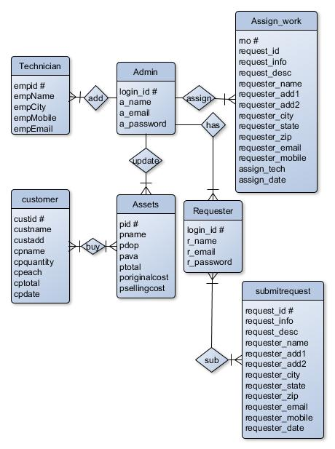

Fig. 3 ER Diagram

5.4Flowchart

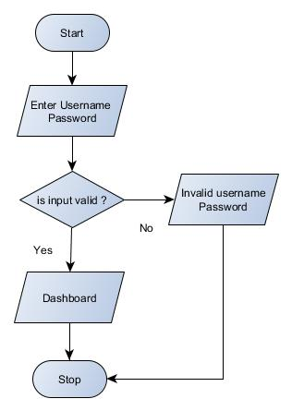**Login Assign Work**

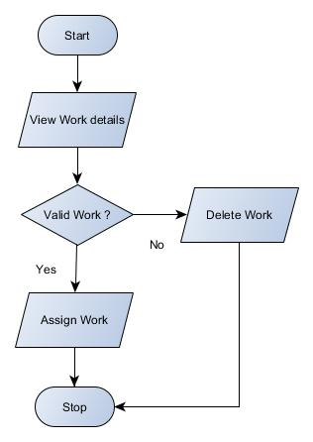

**Sell Product**

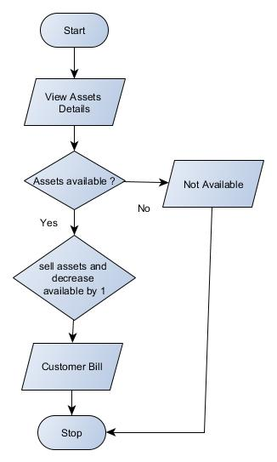

***Chapter-6***

MODULESAND THEIR DISCRIPTION

* **Home**
* **Services**
* **Registration**
* **Contact**
* **Login**
* **User Panel**
* **Profile**
* **Submit Request**
* **Service Status**
* **Change Password**
* **Logout**
* **Admin Login**
* **Admin Panel**
* **Dashboard**
* **Work Oder**
* **Requests**
* **Assets**
  + - **Technician**
    - **Requester**
    - **Sell Report**
    - **Work Report**
    - **Change Password**
    - **Logout**

**Home:**

This module of the web portal contains all the links of the system such as Services, Contact Us, Registration, Login, User Panel, Admin Panel, Technician, Requester, Sell Report, Work Report, Change Password, Logout.

**Services:**

This module describes which services company provides to its customers.

**Registration:**

This System which provides a Registration form where user/requesters can register themselves and submit Service Requests.

**Contact:**

By this module of the web portal the user can contact us.

**Login:**

This module is used to login/signup in the list of the Online Service Management System.

**User Panel:**

This module contains a Profile, Submit Request, Service Status, Change Password, Logout, Admin Login.

**Admin Panel:**

This module contains a Dashboard, Work Oder, Requests, Assets.

**Technician:**

The main work is to accomplish in this module is to add, modify or remove Technician of the Service centre.

**Requester:**

This is the most important module of admin panel where admin can assign the work/requests made by users/requesters.

**Sell Report:**

This module is used to view and prints sell report.

**Work Report:**

This module is used to view and print Work report.

**Change Password:**

User can change his/her login password.

**Logout:**

This Logout and Exit the Application.

***Chapter-7***

INPUT/OUTPUT MODULE

7.1 INPUT TO THE PROJECT

* Requester Registration
* Service Request
* Service Status
* Assign Work
* Assets

7.2 OUTPUT TO THE PROJECT

* Work Order
* Assets List
* Technician List
* Requester List
* Sell Report
* Work Report

***Chapter-8***

PROCESS LOGIC

**Home:**

When the user clicks on this button, it will display the other modules and pages of the website such as Services, Registration, Login, Contact, and Admin Login. This module will be used to display the brief introduction of the project and will show the title of the project as well as the name of the developer.

**Services:**

This module describes which services company provides to its customers.

**Registration:**

This is the most important module of the Online Service Management System which provides a Registration form where user/requesters can register themselves and submit Service Requests.

**Contact:**

This module contains a contact us form which can be used to send feedback or to communicate with the service provider.

**Login:**

This is user login form. When a user clicks on this link a user login form will be appear where user can enter their email id and password for logging in to the user panel.

**User Panel: -**

**Profile:**

User can see their register email id and Name as well as if they wish to change the name, they can update new Name. The Registered Email ID is read only so it can’t be altered.

**Submit Request: -**

Using this module user can submit service request. It is necessary to fill up all the details asked in the form. After submitting form user will get an receipt which he can print out.

**Service Status: -**

User can check their service request status by filling up service request id

**Change Password: -**

User can change his/her login password.

**Logout: -**

This Logout and Exit the Application.

**Admin Login:**

This is Admin login form. When Admin clicks on this link an Admin login form will be appear where admin can enter their email id and password for logging in to the Admin panel.

**Admin Panel: -**

**Dashboard: -**

This screen displays overview of work and other stuff like Number of technician and list of requesters.

**Work Oder: -**

This page contains all the assigned request made by users. Admin can view or delete the assigned work as per their need.

**Requests: -**

This is the most important module of admin panel where admin can assign the work/requests made by users/requesters. If there is any invalid request admin can delete that request without assigning them.

**Assets: -**

The main work is to accomplish in this module is to add, modify or remove any assets of the Service centre. This contains few sub modules through which works are performed. These are as follows:

* New: This is used to add new Product Part in the service centre. There is a Plus (+) sign button which is actually New Button.
* Edit: This sub module is used to modify the existing details of the Product if anything goes changes in their record. There is a Pencil button which is actually Remove Button.
* Remove: This is used to remove any product from the service centre. There is a Trash button which is Remove Button.
* Sell: This is used when going to sell a product Admin can also print out a bill for customer.

**Technician: -**

The main work is to accomplish in this module is to add, modify or remove Technician of the Service centre. This contains few sub modules through which works are performed. These are as follows:

* New: This is used to add new Technician details in the service centre. There is a Plus (+) sign button which is actually New Button.
* Edit: This sub module is used to modify the existing details of the Technician if anything goes changes in their record. There is a Pencil button which is actually Remove Button.
* Remove: This is used to remove Technician from the service centre. There is a Trash button which is Remove Button.

**Requester: -**

The main work is to accomplish in this module is to add, modify or remove Requesters/Users. This contains few sub modules through which works are performed. These are as follows:

* New: This is used to add new Requesters details in the service centre database. There is a Plus (+) sign button which is actually New Button.
* Edit: This sub module is used to modify the existing details of the Requester if anything goes changes in their record. There is a Pencil button which is actually Remove Button.
* Remove: This is used to remove Requester from the service centre. There is a Trash button which is Remove Button.

**Sell Report: -** This module is used to view and print sell report.

**Work Report: -** This module is used to view and print Work report.

**Change Password: -**

User can change his/her login password.

**Logout:**

This Logout and Exit the Application.

***Chapter-9***

DATA DICTIONARY

**Table Name: adminlogin_tb**

|  |  |  |
| --- | --- | --- |
| **Attribute** | **Data Type** | **Description** |
| a_login_id # | int | Stores login id (Automatically Generated) |
| a_name | varchar(60) | Stores Name |
| a_email | varchar(60) | StoreEmail |
| a_password | varchar(60) | Store Password |

**Table Name: requesterlogin_tb**

|  |  |  |
| --- | --- | --- |
| **Attribute** | **Data Type** | **Description** |
| r_login_id # | int | Stores login id (Automatically Generated) |
| r_name | varchar(60) | Stores Name |
| r_email | varchar(60) | StoreEmail |
| r_password | varchar(60) | Store Password |

**Table Name: customer_tb**

|  |  |  |
| --- | --- | --- |
| **Attributes** | **Data Type** | **Description** |
| custid # | int | Customer ID (Automatically Generated) |
| custname | varchar(60) | Customer Name |
| custadd | varchar(60) | Customer Address |
| cpname | varchar(60) | Product Name |
| cpquantity | int | Product Quantity |
| cpeach | int | Each Quantity Price |
| cptotal | int | Total Price |
| cpdate | date | Selling Date |

**Table Name: assets_tb**

|  |  |  |
| --- | --- | --- |
| **Attributes** | **Data Type** | **Description** |
| pid # | int | Product ID (Automatically Generated) |
| pname | varchar(60) | Product Name |
| pdop | date | Product Date |
| pava | int | Number of Available Product |
| ptotal | int | Number of Total Product |
| poriginalcost | int | Product Original Cost |
| psellingcost | int | Product Selling Price |

**Table Name: submitrequest_tb**

|  |  |  |
| --- | --- | --- |
| **Attributes** | **Data Type** | **Description** |
| request_id # | int | Request ID (Automatically Generated) |
| request_info | text | Request Info |
| request_desc | text | Request Description |
| requester_name | varchar(60) | Requester Name |
| requester_add1 | text | Requester Address Line 1 |
| requester_add2 | text | Requester Address Line 2 |
| requester_city | varchar(60) | Requester City |
| requester_state | varchar(60) | Requester State |
| requester_zip | int | Requester Zip |
| requester_email | varchar(60) | Requester Email |
| requester_mobile | bigint | Requester Mobile |
| request_date | date | Request Date |

**Table Name: assignwork_tb**

|  |  |  |
| --- | --- | --- |
| **Attributes** | **Data Type** | **Description** |
| rno # | int | Request Number (Automatically Generated) |
| request_id | int | Request ID |
| request_info | text | Request Info |
| request_desc | text | Request Description |
| requester_name | varchar(60) | Requester Name |
| requester_add1 | text | Requester Address Line 1 |
| requester_add2 | text | Requester Address Line 2 |
| requester_city | varchar(60) | Requester City |
| requester_state | varchar(60) | Requester State |
| requester_zip | int | Requester Zip |
| requester_email | varchar(60) | Requester Email |
| requester_mobile | bigint | Requester Mobile |
| assign_tech | varchar(60) | Assign Technician Name |
| assign_date | date | Assigned Date |

**Table Name: technician_tb**

|  |  |  |
| --- | --- | --- |
| **Attributes** | **Data Type** | **Description** |
| empid # | int | Employee ID (Automatically Generated) |
| empname | varchar(60) | Employee Name |
| empcity | varchar(60) | Employee City |
| empmobile | bigint | Employee Mobile Number |
| empemail | varchar(60) | Employee Email ID |

***Chapter-10***

TOOL AND PLATFORM

10.1 Hardware specification

|  |  |
| --- | --- |
| Processor | 1.6 GHz or Faster Processor |
| RAM | 1.5 GB |
| Disk Space | 4GB of Available Hard Disk |
| Graphic | DirectX 9-Capable Video Card |
| Display | 1024 X 768 or Higher Resolution |

10.2 Software specification

|  |  |
| --- | --- |
| Operating System | Windows 10 |
| Front End | HTML, CSS, JS |
| Frameworks/Library | Bootstrap, FontAwesome, Google Font |
| Back End | PHP |
| Text Editor | Visual Studio Code |
| Database | MySQL |
| Web Browser | Google Chrome |
| Web Server | Apache |
| Drawing Tools | yEd Graph Editor |
| StarUML |

***Chapter-11***

REASONS FOR USING PHP AND MYSOL

11.1 Reasons for using PHP

PHP is an open source language and all its components are free to use and distribute.

PHP is server-side scripting language. It is embedded in HTML source code. It is used to generate dynamic pages content. People find it useful to develop websites and dynamic web pages. It is platform independent. PHP supports all major web servers such as Apache, Microsoft IIS, and Netscape etc. All the major database such as MySQL, PostgreSQL, oracle, Sybase, Microsoft SQL server is supported by PHP.

The main reasons for using PHP language are:

* It collects form data and save data send by mail.
* It sends and receives cookies by accessing cookies variables.
* It provides add, delete, and modify element function within our database.
* Through PHP, we can restrict users to access some pages of our website.
* It can encrypt data, so that our data will become more secure.

11.2 Reason for using MySQL****

MySQL is the most popular open source relational database management system. It is one of the best RDBMS being used to develop web-based software applications. It is easy to use and fast RDBMS.

There are many good reasons which help us to develop website using this RDBMS:

* It is open-source, so available for free.
* IT works on many operating system and with many languages including PHP, PERL, C, C++ etc.
* MySQL is customizable.
* MySQL works very quickly and works well even with large data sets.

***Chapter-12***

ARE YOU DOING THIS PROJECT FOR ANY INDUSTRY/CLIENT?

No, I am not doing this project for any industry/client.

***Chapter-13***

LIMITATIONS

* SMS alert facility is not available.
* Portal is not SEO friendly
* Registration Email Verification Not available
* Risk unauthorized accessibility

***Chapter-14***

FUTURE SCOPE

The various things can be made it simple and user friendly. As by increasing some of the coding we can improve it functionality. online payment system is yet not integrated to the system which can be featured in the near future.

Till now it does not have the facility of back up the database. By as the next advancement we can make it able to bundle the backup facility so that one can perform operation based on previous records.

As the technology emerges, it is possible to upgrade the system and can be adaptable to desired environment.

Based on the future security issued, security can be improved using emerging technologies.

***Chapter-15***

REFRENCES

The following reference has been used to develop the project “Online Service Management System” :-

**Books: -**

* The Complete Reference PHP
* Head First SQL: Your Brain on SQL by Lynn Beighley

**Web Source: -**

* www.google.co.in
* www.wikipedia.org
* www.tutorialspoint.com
* www.stackoverflow.com
* www.docs.microsoft.com